**How to perform Distributed Testing in JMeter**

**Overview**

Distributed Testing is a kind of testing which use multiple systems to perform Stress Testing. Distributed testing is applied for testing web sites and server applications when they are working with multiple clients simultaneously.

Distributes testing uses client-server model as figure below:

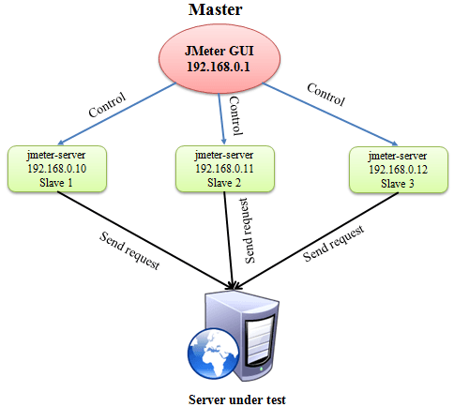

* **Master**: the system running JMeter GUI, control each slave.
* **Slave**: the system running jmeter-server, receive command from the master and send a request to server under test.
* **Target**: the web server under test, get request from slaves.

**Start your test**

**Precondition:**

* The firewalls on the systems are turned off. In some cases, the firewall may still be blocking the traffic. You should disable the Window firewall or Linux firewall.
* All the machines should be on same subnet. If machines are not on same subnet, maybe they will not recognize each other in the network.
* Use the same version of JMeter to avoid unanticipated errors/issues.

Here is the **roadmap** of this testing:

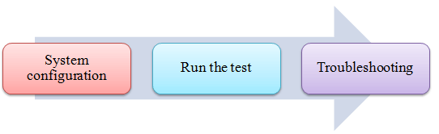

**Step 1) System configuration**

On the **slave** systems, go to jmeter/bin directory and execute file "jmeter-server.bat".

Assume that a slave machine has IP address: 192.168.0.10. On windows, you should see a window appear like following figure:

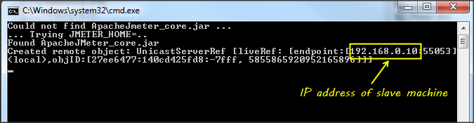

On the **master** systems, go to /bin directory and edit file **jmeter.properites**, add IP slave machine as below

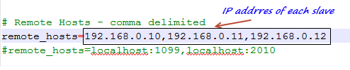

## Step 2) Run the test

On the master machine, run JMeter GUI and open the test plan.

Click Run on the menu bar; select **Remote start** **->**select **the IP address** of slave machine

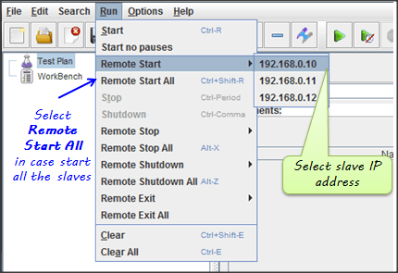

## Step 3) Troubleshooting

If you are unable to run test form the above machine and see below error, simply ask owner of slave machine to run the jmeter-server.bat File.

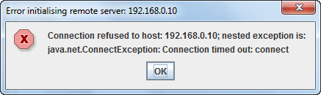

### Limitation:

There are some basic **limitations** for distributed testing. Here's list of the known items:

* Server and all clients must be on **the same** subnet.
* Distributed testing required target server to have large processing power. The target Server could be easily **overloaded** in case it gets too many requests by distributed JMeter tests.
* A single JMeter can only handle a limited number of threads (100- 300 threads).
* The distributed JMeter tests are complex, difficult for beginner to build.